HIRDA-BF Blast furnace charge level
Infrared thermal imaging online temperature detection and analysis system
Technical Solution

CONTENTS
1 Overview 3
2 System Introduction 3
2.1 Product Description 3
2.2 System Features 4
2.3 System Utility Requirements 5
2.3.1 power supply 5
2.3.2 Compressed air or nitrogen 5
2.3.3 Cooling water 5
3 Application Scenario 5
4 Main technical indicators 5
5 System composition 6
5.1 High temperature resistant probe 6
5.2 High temperature resistant infrared lens 6
5.3 Pneumatic advance and retreat device 6
5.4 Embedded parts 7
5.5 Control cabinet 8
5.6 Stainless steel hose 9
5.7 High temperature resistant cables 9
5.8 Optical cable and interface (on demand) 10
6 System Software 10
7 System wiring diagram 12
8 Configuration List 12
9 Division of labor between the two parties 12
10 Acceptance Criteria 13
11 After-sales commitment 13
HIRDA-BF Blast furnace charge level
Infrared thermal imaging online temperature detection and analysis system
Technical Solution

1 Overview
Blast furnace is an ironmaking equipment and the first step in steelmaking. Iron ore is smelted in a blast furnace to produce pig iron for various purposes or molten iron for steelmaking.
The blast furnace production process is the process of smelting iron ore into pig iron at high temperatures. Iron ore, coke, and slag-making flux (limestone) are loaded from the top of the furnace, and preheated air is blown in from the tuyere located at the bottom of the furnace along the furnace periphery. Under high temperature, the carbon in the coke (some blast furnaces also spray auxiliary fuels such as coal powder, heavy oil, and natural gas) and the oxygen in the blown air undergo combustion reactions, producing high temperature and reducing gases. These reducing gases heat the slowly descending charge during the rising process and reduce the iron oxides in the iron ore into metallic iron.
Blast furnace ironmaking is a relatively complex process. It is necessary for blast furnace operators to easily understand the temperature distribution in the entire furnace before and after charging, the direction of airflow, and the distribution of pipe leakage, material collapse, and material surface inclination, so as to operate charging scientifically and reasonably. At the same time, they can also observe the operating conditions of other equipment in the furnace, such as: chute, cross temperature measurement, probe, etc.
Therefore, timely acquisition of information inside the blast furnace during the smelting process helps blast furnace operators to better control the blast furnace, change from passive to active operation, avoid accidents, and enable the blast furnace to achieve the goals of safety, stable production, high output, low consumption and long life, thereby achieving good social benefits and huge economic benefits.

2 System Introduction

2.1 Product Description
HIRDA-BF blast furnace surface infrared thermal imaging online temperature detection and analysis system is a special equipment used to detect the temperature distribution of the surface in the blast furnace. The system consists of infrared thermal imaging core, high temperature resistant infrared thermal imaging lens, automatic retraction protection device, furnace installation kit, air filtration system and field equipment box, algorithm server and intelligent temperature measurement software.
The high-temperature resistant infrared thermal imaging lens is installed in a retractable metal protective cover. The high-temperature resistant infrared thermal imaging lens is directly extended into the furnace through the retractable device. The infrared thermal imaging core stays outside the furnace to realize continuous real-time monitoring of the working status of the furnace.
The protective cover is cooled by compressed cooling air to make the infrared lens work at a more suitable temperature; at the same time, the lens is purged to prevent the dust in the furnace from adhering to the lens protection window; the system has a built-in high-temperature protection circuit. Once the cooling gas or cooling water circulation is abnormal, the lens will be retracted to prevent damage by the high temperature in the furnace.
It has the characteristics of high temperature resistance, corrosion resistance and maintenance-free. It can display various complex working conditions inside the blast furnace in real time. When the camera probe purges compressed air normally, it is suitable for various positive pressure kilns.
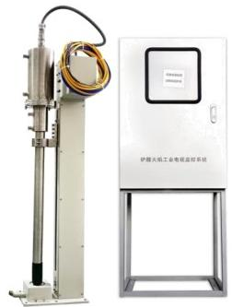
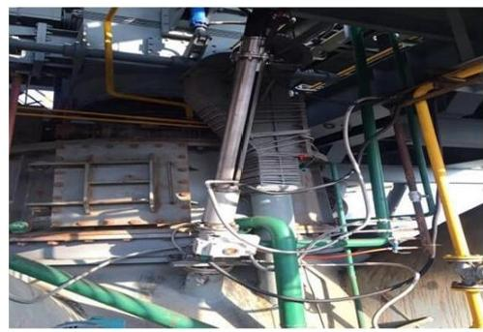

Figure 1 HIRDA-BF blast furnace charge surface infrared thermal imaging online temperature detection and analysis system product and installation diagram

2.2 System Features
◆With all-weather passive infrared temperature measurement function, real-time display of the temperature distribution of the material surface in the furnace
◆Adopt self-developed temperature measurement and correction algorithm to achieve accurate temperature measurement
◆Fully sealed to ensure that blast furnace gas does not leak
◆Ultra-large viewing angle, diagonal viewing angle can reach 120°
◆Spiral air curtain design, no dust accumulation on the lens
◆Overall stainless steel material, corrosion and temperature resistance
◆Automatic exit protection device, exit fault indication
◆Pneumatic/electric transmission mechanism
◆High temperature resistant optical pinhole lens, with dust-proof high temperature lens
◆Automatic exit from the furnace in case of over-temperature, under-voltage, and power failure
◆Support onvif protocol, can be connected to mainstream NVR
◆Not dependent on the system platform, can directly log in to the ip on the web page to access images and configurations, can directly output alarm signals to PLC or alarm

2.3 System Utility Requirements

2.3.1 power supply

Field probe power supply： 220VAC 50/60HZ power 150W/set
Control room power supply： 220VAC 50/60HZ power 100W

2.3.2 Compressed air or nitrogen
Compressed air temperature: ≤35℃
Compressed air pressure: ≥0.4 Mpa
Compressed air flow: 0.1-0.2m³/Min

2.3.3 Cooling water
Cooling water temperature: ≤35℃
Cooling water pressure: ≥0.4 Mpa
Cooling water flow: 30 liters/Min

3 Application Scenario
Observe the material surface conditions inside the blast furnace, and fully grasp the chute operation status, chute lining wear degree, chute unloading conditions, chute hanging status, chute operation status and other information.

4 Main technical indicators

Operating ambient temperature | Furnace temperature |  | ≤2000℃
Operating ambient temperature | Control System |  | ≤80℃
Automatic exit device | Automatic exit protection function |  | The probe can automatically withdraw from the furnace in case of power failure, gas failure, over-temperature or under-pressure.
Automatic exit device | Exit device trip |  | 100-800mm, can be customized according to furnace thickness
Automatic exit device | Manual in and out function |  | have
Controls | Integrated touch screen system |  | 8 relays, 4 transistors
Controls | Three-site control |  | It can realize the operation from three places: on-site central control and mobile phone
Infrared thermal imaging | Detector type |  | Uncooled focal plane detector
Infrared thermal imaging | Resolution |  | 640×480、384×288
Infrared thermal imaging | Field of view |  | Diagonal 120°
Infrared thermal imaging | Lens type |  | High temperature resistant pinhole lens
Infrared thermal imaging | Temperature measurement range |  | 50℃~1600℃
 | Temperature measurement accuracy |  | ±2℃ or 2%
 | Network Protocol |  | support  ONVIF/RTSP/FTP/PPPOE/DHCP/DDNS/NTP/UPnP/TCP
Vortex cooling tube  (optional) | When the compressed air inlet is ≥0.35MP, the compressed air outlet temperature difference is 23 degrees
Protection level | IP67
Power supply requirements | Supply voltage | AC220V±10%
Power supply requirements | Supply frequency | 50Hz
Installation distance | The maximum distance between the equipment and the on-site control box is 15M

5 System composition

5.1 High temperature resistant probe
The high temperature resistant probe adopts an integrated design and has protection functions against high temperature, high pressure, corrosion, power failure, gas failure, etc. The integrated probe integrates a high temperature infrared lens, infrared thermal imaging and a pneumatic advance and retreat device.
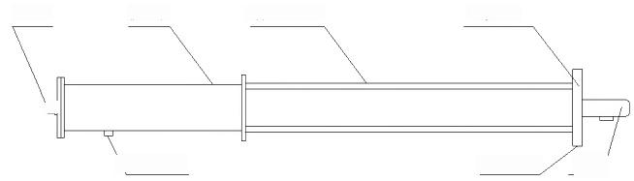
进气口 防护罩 气动进退装置 连接法兰

气缸进气口 气缸进气口 探头/

5.2 High temperature resistant infrared lens
The high temperature resistant infrared lens housing is made of stainless steel, the front end imaging adopts the micro-hole imaging principle, and the flange connection port is reserved for connection with the infrared thermal imaging.
The technical parameters are as follows:
◆Viewing angle: diagonal viewing angle 120°;
◆High temperature resistance: < 2000℃;
◆Low temperature resistance: -40℃;
◆Cooling medium: compressed air (oil-free and water-free);
◆Air inlet: Φ12, ZG1/2";
◆Air inlet pressure: 0.1～0.4MPa;
◆Cylinder air inlet: Φ 12, ZG1/4";
◆Environmental humidity: 10~90%, no condensation.
5.3 Pneumatic advance and retreat device
The high temperature resistant probe is integrated inside the pneumatic transmission device, and the camera probe is moved forward and backward by the reciprocating motion of the cylinder piston. Advance and retreat indicators are installed on both sides of the front end of the pneumatic device to indicate the "advance" and "retraction" of the camera probe. The internal components of the cylinder are made of high temperature resistant and wear-resistant materials, suitable for operation in high temperature, corrosive and high dust environments.
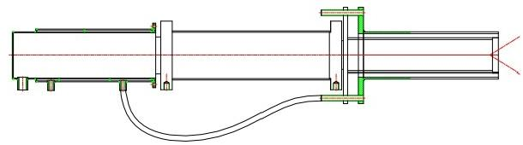
The main technical parameters are as follows:
◆ Cylinder diameter: Φ100mm
◆ Working stroke: can be customized according to the thickness of the furnace wall
◆ Ambient temperature: -40℃~250℃
◆ Air inlet: Φ12, ZG1/4"

5.4 Embedded parts
When installing the equipment, the embedded parts are pre-installed in the monitoring hole, and a special flange is connected to the camera probe. The embedded parts are made of high-temperature resistant stainless steel and are equipped with a special installation guard plate to close the surrounding of the monitoring hole and connect the embedded parts. The camera probe advance and retreat indicator pointers are installed on both sides of the embedded parts, and an automatic door is installed at the rear end of the embedded parts. When the camera probe is pushed forward, the automatic door is pushed open by the front end of the probe. When the camera probe is withdrawn, the automatic door automatically closes to protect the camera probe from being damaged by high-temperature dust inside the kiln after it exits the monitoring position due to the lack of protective compressed air.
The main technical parameters are as follows:
◆ Installation diameter: Φ110 (standard)
◆ Embedment depth: determined by the thickness of the furnace wall
◆ Ambient temperature: < 2000℃
◆ Cooling medium: compressed air
◆ Air inlet: Φ 1 2, ZG1/2"

5.5 Control cabinet
The control cabinet provides working power to the camera probe and fully automatically controls the advance and retreat of the probe. It receives the coded instructions from the transport and drives the various control functions of the camera probe after conversion. The control cabinet can control the camera probe by connecting to the operation controller.
The main technical parameters are as follows:
◆Power supply: 220 VAC/50Hz
◆Power consumption: 50W
◆Control input: RS485
◆Control output: switch
◆Power output: 12VDC/1.5A
◆Video input: IP network
◆Video output: network, optical fiber SC interface
◆Temperature control: 0-60 degrees
◆Air supply index: 0.4MPa～1MPa, temperature ≤40℃, flow ≥3m³/h
◆Air outlet index:
◆Cooling air: 0.1MPa～0.4MPa, flow ≥2m³/h
◆Purge air: 0.1MPa～0.4MPa, with self-contained air filtration, flow ≥0.2m³/h
◆Protection grade: IP65
◆Dimensions: 700(width)×500(height)×200(depth)
◆Mounting hole size: 640(width)×400(height)×Φ10

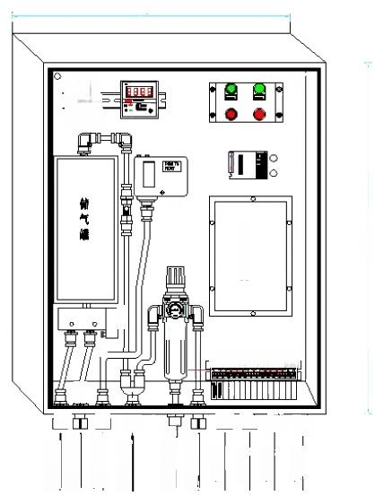
風上道逆
500

o0 8= 合

O

断
ooooooo
草
面
章头吹气
过算排度口
樂头思出 案头钟堪
走老孔
走着孔
走就孔
走粪孔
百 西
面
面 西
主 控 制 花
总 进 气
可
目

5.6 Stainless steel hose
Stainless steel hoses are resistant to high temperatures, high pressures and corrosion. To facilitate the movement of the camera probe, the cables and compressed air connected to the camera probe use stainless steel hoses as the connecting medium.
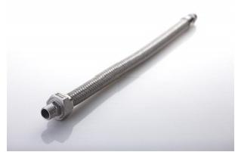
◆ Diameter: Φ12, Φ10, Φ8, Φ6
◆ Interface: ZG1/2"
◆ Material: Heat-resistant stainless steel

5.7 High temperature resistant cables
Since the ambient temperature at the work site is generally high, in order to ensure the stability and reliability of communication and video transmission, the cables are selected to be high temperature resistant, fire resistant, and shielded cables.
The main technical parameters are as follows:
◆Rated temperature: -65℃~+250℃ (maximum ambient temperature: 250℃, minimum ambient temperature: -65℃)
◆Rated voltage: 600V
◆Implementation standard: GJB773A-2000
◆Conductor: multi-strand tinned copper wire
◆Color: red, black DC12V 0.5m²; orange-white, orange, green-white, green, blue-white, blue, gray-white, gray network cable.
◆Insulator: polytetrafluoroethylene (PTFE)
◆Performance: corrosion resistance, strong acid resistance, strong alkali resistance, oxidation resistance; high voltage resistance, non-flammable, non-aging
◆Test voltage: 7000V without breakdown

5.8 Optical cable and interface (on demand)
The control signals and video signals for long-distance transmission are all transmitted using single-mode optical fiber. Optical fiber transmission has the characteristics of high signal quality and anti-interference, and the signal transmission distance can reach more than 20km. In addition, the system is equipped with SC type optical cable interface to facilitate optical cable connection. The technical parameters are as follows:
◆ Optical fiber type: single mode
◆ Working wavelength: 13l0nm and 1550nm
◆Attenuation characteristics: 13l0nm wavelength is 0.36dB/km; 1550nm wavelength is 0.21dB/km
◆ Bending loss: Φ75×100 turns, additional bending loss ≤0.5dB
◆ Optical fiber interface: single-mode SC

6 System Software
The system client software interface is shown in the figure below:
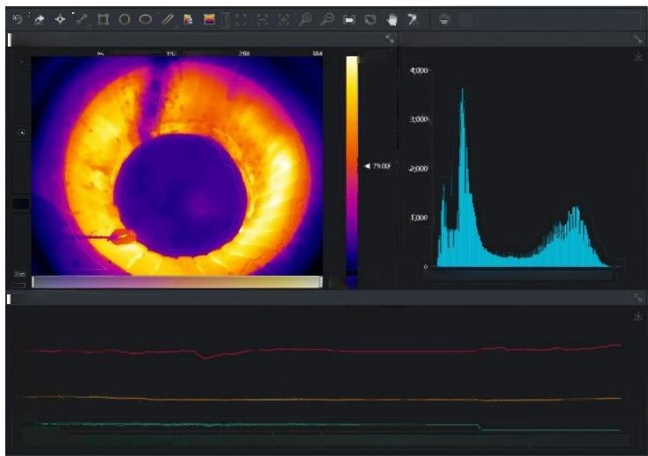

成图100%)
温度直方图
13700

192温度曲线
■Max412055206920832097201112012520

Ag160
140
120
100
80
60
0

0000400000000.800000001200000001600

0000020

0000240000002800000003200000003600 0000040 000004400
4100
a
Min
Figure 2 System software interface

The basic functions of the software are as follows:
1. Real-time video display of the material surface in the furnace: it can clearly observe the center position of the airflow, the distribution of the edge airflow, the shape of the chute, the wear degree of the chute lining, the material discharge condition of the chute, the hanging state of the chute, the operation condition of the chute, etc.
2. Real-time display of the full radiation thermal map of the material surface in the furnace, you can view the temperature at any position in the infrared thermal map, the temperature display frequency can be set, the default setting is the same as the cycle of one circle of the chute, and the temperature is collected when the chute rotates to the opposite side of the system installation.
3. Temperature tracking: automatically display the highest and lowest temperature points, highlight the specified temperature range; according to the habits of the blast furnace operator, the effect of "cross temperature measurement" can be achieved.
4. Data capture: thermal imaging image data can be collected regularly for later analysis.
5. High temperature trigger shooting and alarm: when the temperature is abnormal, the background can be discovered in time and the alarm is triggered. The software background will take infrared pictures and visible light pictures during the incident.
6. Fault self-diagnosis: when the terminal equipment fails, the system automatically alarms.
7. Customized alarm thresholds and levels: The system can define multiple different alarm thresholds and levels to assist staff in assessing the urgency and development trend of hidden dangers.
8. Data recording: The operation status of the blast furnace can be recorded regularly. The calculation results of each thermal image and the image itself can be recorded in the computer, and the existing records can be called up for playback at any time.

7 System wiring diagram

HIRDA-BF system connection diagram

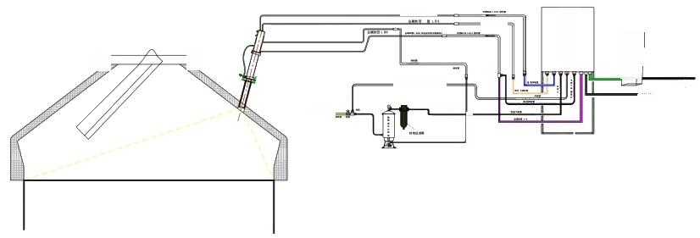
n
控 制 柜

牙 卡
黑
白色 r管压力
CS/HC
供电
C22
格
山 也 H 牧 管
直经2 mN 软

Figure 3 System wiring diagram

8 Configuration List

Serial number | name | model | unit | quantity | Remark
1 | Infrared thermal imaging for blast furnaces | HIRDA-BF-NX26Exx | Taiwan |  | Resolution:  Focal length:  Temperature measurement range:
2 | High temperature resistant probe | HIRDA-HTP | piece
3 | Pneumatic advance and retreat device | HIRDA-CY | piece
4 | Embedded parts | HIRDA-EMB | piece
5 | Control cabinet | SEB752 | piece
6 | Image algorithm server | IDS | piece |  | Including hardware and software, display
7 | Air compressor | YBM-15A | set |  | Optional
8 | Cold dryer | S-100AFB | Taiwan |  | Optional
9 | High temperature metal hose | φ12mm | Taiwan
10 | High temperature hose | φ12mm | set
11 | Matching cables | / | set
12 | Installation accessories | HIRDA-FJ | set

9 Division of labor between the two parties
Supplier:
1) Provide manufacturing, transportation, installation guidance and commissioning services for HIRDA-BF blast furnace surface infrared thermal imaging online temperature detection and analysis system to ensure the normal operation of the system, ensure the integrity of the system, and meet the requirements of on-site use.
2) Responsible for selecting the installation location of the HIRDA-BF blast furnace surface infrared thermal imaging online temperature detection and analysis system equipment, and provide the equipment installation location map before construction.
3) Responsible for training the commissioning, use, maintenance and overhaul of the HIRDA-BF blast furnace surface infrared thermal imaging online temperature detection and analysis system for the purchaser's personnel, so that the purchaser's personnel can master the operating skills independently.
4) Provide product certificates, inspection reports, use and maintenance instructions and other relevant technical information.
Buyer：
1) Provide relevant on-site information and design drawings required for the installation and commissioning of the HIRDA-BF blast furnace surface infrared thermal imaging online temperature detection and analysis system equipment.
2) Open holes at appropriate locations in the kiln and weld embedded parts for equipment installation according to design requirements.
3) Undertake the piping, wiring and fiber fusion work of cooling air, cooling water, optical fiber and cables required for the HIRDA-BF blast furnace material surface infrared thermal imaging online temperature detection and analysis system equipment.
4) Determine whether the site has the installation conditions required by the supplier, and notify the supplier's technical personnel in advance to participate in the guidance of installation and commissioning.
5) The buyer assists in providing working conditions for the supplier's factory service personnel.

10 Acceptance Criteria
1) The production status of the kiln material surface can be displayed on the software interface of the HIRDA-BF blast furnace material surface infrared thermal imaging online temperature detection and analysis system. When the cooling air and cooling water meet the use requirements, the thermal imager maintains a good working effect;
2) The system is equipped with cooling water flow monitoring, cooling air pressure monitoring, in/out device, and equipment temperature monitoring device. In the case of insufficient cooling air and cooling water pressure or interruption of cooling air and cooling water, or excessive temperature of the thermal imager, the system will automatically exit to ensure the safety of the thermal imager and high-temperature lens;
3) The supplier provides professional training to the designated personnel of the purchaser.

11 After-sales commitment
1) The warranty period of HIRDA-BF blast furnace surface infrared thermal imaging online temperature detection and analysis system is 12 months from the date of acceptance or 18 months after the equipment arrives (the warranty period of purchased products, servers and internal hardware is 12 months from the date of equipment arrival).
2) If the thermal imager is damaged due to water or gas outage, the buyer shall order spare parts in time and the supplier shall provide maintenance services.
3) The HIRDA-BF blast furnace surface infrared thermal imaging online temperature detection and analysis system is used for a long time, and software upgrade services are provided free of charge.
4) When receiving a call from the buyer, the supplier is responsible for guiding the buyer to handle the fault; if the buyer cannot solve it, the supplier promises to rush to the site to handle it within 48 hours. Company service phone: 400-080-4288.

