**HIRDA-L**

**Intelligent ladle analysis and diagnosis system**

**Technical solution**

**Wuhan Huajingkang Optoelectronics Technology Co., Ltd.**

**January 2024**

CONTENTS

1 Overview 3

2 System Introduction 4

2.1 Product Description 4

2.2 System Features 5

2.3 System Utility Requirements 5

2.3.1 power supply 5

3 Application Scenario 5

High-temperature metal solution transfer containers such as steel ladles and iron ladles 5

4 System composition 5

4.1 High temperature infrared thermal imaging thermometer 5

4.2 Overall size 6

4.3 On-site control box 6

4.4 Stainless steel hose 7

4.5 High temperature resistant cables 7

4.6 Optical cable and interface (on demand) 8

4.7 Multi-function server 8

5 System Software 9

5.1 Software interface 9

5.2 Software Features 10

5.2.1 Ladle 2D/3D display function 10

5.2.2 Automatic identification function of ladle number 10

5.2.3 Automatic detection and positioning of ladle high temperature area 11

6 Configuration List 11

7 On-site installation diagram 12

8 Division of labor between the two parties 12

9 Acceptance Criteria 13

10 After-sales commitment 13

HIRDA-L Ladle Intelligent Diagnosis and Analysis System

Technical Solution

**1** **Overview**

As an important container for transporting molten steel and performing secondary metallurgical reactions in converter and continuous casting sections, the management and dispatch of the ladle plays an important role in optimizing the operation and energy saving and consumption reduction of steel plants. The ladle is composed of barrel, lining, nozzle opening and closing device and air-permeable bricks. The main function of the ladle is to receive the molten steel and part of the slag flowing out of the tapping door of the primary steelmaking furnace (converter or electric furnace). The ladle can calm the molten steel for a period of time to adjust the temperature of the molten steel, make the composition uniform and make the non-metallic inclusions in the molten steel float. At the same time, the steel flow is opened and closed during the pouring process to control the flow of molten steel and ensure smooth pouring.

In recent years, major accidents in the metallurgical industry have frequently occurred due to safety hazards such as overheated molten steel (iron) breaking through the ladle, severe wear of the ladle lining, and fatigue damage during the iron and steel making process, posing a serious threat to production safety.

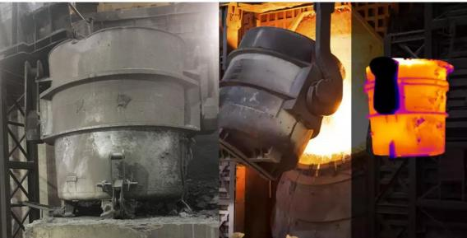

Practice has shown that the initial defects of the ladle lining will gradually develop from point to surface until complete failure. When the lining is peeling off in the early stage, the temperature of the peeling point area will be abnormally high, and the temperature of the defective area will be significantly higher than that of other locations.

Therefore, using infrared thermal imagers to achieve rapid online detection and diagnosis can timely detect abnormal temperature changes in equipment, locate defective parts, avoid safety accidents in time, and ensure normal production operations.

**2** **System Introduction**

**2.1 Product Description**

HIRDA-L steel ladle intelligent diagnosis and analysis system is a high-tech system specially used to detect the temperature of steel ladle shell and conduct intelligent analysis. The system consists of high-temperature infrared thermal imaging thermometer, high-definition visible light camera, electric control box, algorithm server and client management software. It centrally monitors and manages the equipment on the operation site, and realizes data collection, analysis, high temperature point positioning, automatic alarm and ladle number recognition through digital transmission network.

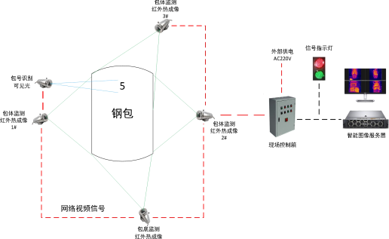

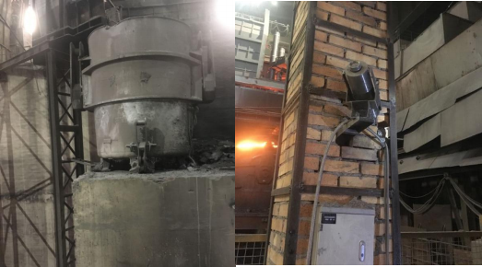

Figure 1 HIRDA-L ladle intelligent diagnosis and analysis system block diagram and product diagram

**2.2 System Features**

u With all-weather passive thermal imaging function；

u Adopt self-developed temperature measurement and correction algorithm to achieve accurate temperature measurement；

u Strong environmental adaptability, can be used in harsh environments such as high temperature and high dust；

u Automatic identification of ladle numbers and intelligent association of temperature data；

u 360° all-round temperature detection of the ladle, 3D schematic diagram showing the temperature distribution of the ladle；

u 1 square decimeter high temperature area automatic positioning warning；

u Establish the corresponding model between the refractory material of the ladle and the surface temperature of the ladle；

u Establish a surface temperature database for each ladle life cycle;

u Open interface, providing SDK development kit, can be connected with DCS, PLC and other systems.

**2.3 System Utility Requirements**

**2.3.1 power supply**

On-site probe power supply: 220VAC 50/60HZ Power 150W/set

Control room power supply: 220VAC 50/60HZ Power 100W

**3** **Application Scenario**

High-temperature metal solution transfer containers such as steel ladles and iron ladles.

**4** **System composition**

**4.1 High temperature infrared thermal imaging thermometer**

|  |  |
| --- | --- |
| Detector type | Uncooled focal plane microbolometer |
| Image resolution | 384×288 、640×480 |
| Lens options | 4 、8 、13 、19mm |
| Wavelength range | 8～14μm |
| Thermal sensitivity (NETD) | ≤50mk@30℃ |
| Frame rate | 25Hz |
| Focus | Electric/Automatic |
| Temperature measurement accuracy | ±2℃or±2% |
| Temperature measurement range | -20℃~650℃ |
| Data type | H264 、H265 、16Bit Raw temperature data |
| Network standard | Gigabit Ethernet/Adaptive 10M/ 100M/ 1000M |
| Protocol support | IPv4/ IPv6、TCP、UDP、NTP、HTTP、RTSP、RTP、ICMP、WebSocket、 ONVIF |
| ladle number recognition sensor | High-definition visible light |
| Resolution | 2 million, 3 million, 5 million optional |
| Protection level | IP66 |
| Dimensions | Φ126mm×313mm |
| Mounting method | Equipped with PTZ bracket |
| Weight | ≤8Kg |
| Operating temperature | -20～60℃ |
| Storage temperature | -50℃~70℃ |
| Temperature shock resistance | 5℃/min (-40℃~60℃) |
| Vibration resistance | 4.3g, 2 hours for each axis of x, y, z |
| Shock resistance | Acceleration 30g, half sine wave, pulse width 6ms, 3 times of impact in the installation direction |
| Humidity | ≤95% (non-condensing) |

**4.2 Overall size**

The overall structure dimensions are shown in the figure below:

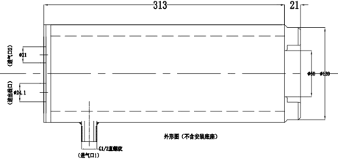

**4.3 On-site control box**

The electric control cabinet contains an industrial Ethernet switch (photoelectric conversion) and a power adapter. Its main function is to provide a stable power supply for the infrared thermal imager, network switching (photoelectric conversion), and data conversion.

u Input interface: 100M/1000M Ethernet, RJ45 interface

u Output interface: 1000M optical port

u Transmission rate: up to 1000M

u Standard: IEEE802.3, IEEE802.3u, IEEE802.3x

u Power supply: AC 220V±10% 50W

u Ambient temperature: -20℃~65℃

u Ambient humidity: ≤90%

u Dimensions： 400（W） ×300（H） ×200（D）mm

u Dimensional drawings

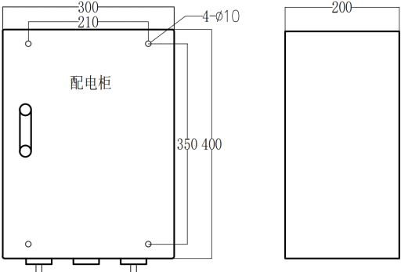

**4.4 Stainless steel hose**

Stainless steel hoses are resistant to high temperature, high pressure and corrosion. To facilitate the movement of the camera probe, the cable and compressed air connected to the camera probe use stainless steel hoses as the connecting medium.

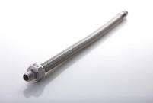

u Path： Φ12 、 Φ10 、 Φ8 、 Φ6

u Interface：ZG1/2 ″

u Material：Heat resistant stainless steel

**4.5 High temperature resistant cables**

As the ambient temperature at the work site is generally high, in order to ensure the stability and reliability of communication and video transmission, the cables are selected to be high temperature resistant, fire resistant, and shielded cables.

The main technical parameters are as follows：

u Rated temperature: -65℃~+250℃ (maximum ambient temperature: 250℃, minimum ambient temperature: -65℃)

u Rated voltage：600V

u Implementation Standards：GJB773A-2000

u Conductor: multi-strand tinned copper wire

u Color: red, black DC12V 0.5m2; orange and white, orange, green and white, green, blue and white, blue, gray and white, gray network cable

u Insulator: Polytetrafluoroethylene (PTFE)

u Performance: corrosion resistance, strong acid resistance, strong alkali resistance, oxidation resistance; high voltage resistance, non-flammable, non-aging

u Test voltage: 7000V without breakdown

**4.6 Optical cable and interface (on demand)**

The control signals and video signals transmitted over long distances are all transmitted using single-mode optical fiber. Optical fiber transmission has the characteristics of high signal quality and anti-interference, and the signal transmission distance can reach more than 20km. In addition, the system is equipped with SC type optical cable interface to facilitate optical cable connection. The technical parameters are as follows:

u Fiber type: Single mode

u Operating wavelength: 1310nm and 1550nm

u Attenuation characteristics: 1310nm wavelength is 0.36dB/km; 1550nm wavelength is 0.21dB/km

u Bending loss: Φ75×100 turns, additional bending loss ≤0.5dB

u Fiber optic interface: single mode SC

**4.7 Multi-function server**

u Intel® Core™ i7-11700 processor (quad-core, 8MB, 3.60GHz)

u Memory 16GB (2x4GB) 1600MHz DDR3 Non-ECC

u Hard Drive 256G SSD + 1TB 3.5-inch SATA (7,200 Rpm) Hard Drive

u Monitor 23.8 inches

u Windows 10 Pro, 64-bit operating system

**5** **System Software**

**5.1 Software interface**

The system client software interface is shown in the figure below

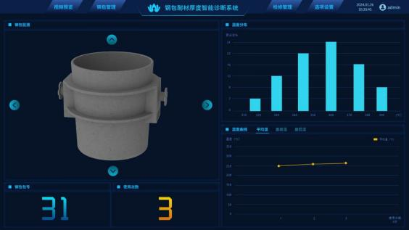

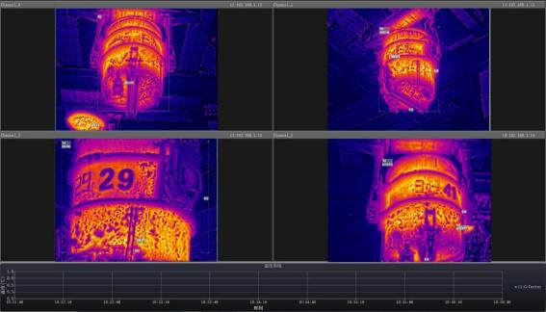

Figure 2 System software interface

The basic functions of the software are as follows：

u Real-time video display: Real-time display of full radiation thermal images and high-definition visible light videos, which can check the temperature at any location in the infrared thermal image, and record, take photos, and analyze abnormal situations.

u Temperature tracking: Automatically analyze the temperature rise trend of the entire infrared thermal image or a specific area to detect potential dangers early.

u Data capture: Thermal imaging image data can be collected regularly for later analysis.

u High temperature triggers shooting and alarm: When abnormal temperature occurs, the background can detect it in time and trigger the alarm. The background of the software will take infrared and visible light pictures of the incident.

u Fault self-diagnosis: When a terminal device fails, the system automatically alarms.

u Customizable alarm thresholds and levels: The system can define multiple alarm thresholds and levels to assist staff in assessing the urgency and development of potential hazards.

**5.2 Software Features**

**5.2.1 Ladle 2D/3D display function**

The ladle is a cylindrical structure. The curved surface is unfolded and a two-dimensional coordinate system is constructed with 1dm as the minimum unit. The ladle wall is divided into about 7087 1dm2 areas, and the ladle bottom is divided into about 118 1dm2 areas. The mapping relationship between the two-dimensional coordinate system and the three-dimensional coordinate system is constructed. The MySQL database is used to manage the data. The database mainly consists of the ladle information table (ladle number, name, manufacturer, activation date, number of uses, number of slag lines, number of air bricks, slides, number of nozzles used, etc.), the block information table (block number, ladle number, two-dimensional coordinates, three-dimensional coordinates, lining residual thickness, etc.), and the temperature record table (block number, maximum temperature, minimum temperature, average temperature, and recording time).

Use multiple infrared thermal imagers to measure the temperature of each part of the ladle and record infrared pictures or videos containing temperature data.

Combine the lens focal length, shooting distance and other parameters to map the infrared thermal image with the expanded image of the ladle surface.

Render the 3D model of the ladle, using 1dm2 as the basic unit to display different colors for different temperature blocks according to different color palettes. When the mouse points to an area, the relevant data of the area is displayed.

Features are as follows：

1) The ladle wall is divided into approximately 7087 1 dm2 areas, and the ladle bottom is divided into approximately 118 1 dm2 areas.

2) Using 1 square decimeter as the basic unit, the 2D/3D temperature field diagram of the ladle wall and bottom is displayed, and different temperatures are distinguished by color.

**5.2.2 Automatic identification function of ladle number**

1) When the ladle moves to a fixed position, the system automatically detects and identifies the ladle number and records the identification date and time, with the time accurate to the minute；

2) After the system successfully identifies the ladle number, the "thermal imaging times" value and the "furnace number" value are increased by 1, and the "furnace number" value is equal to the "thermal imaging times" value by default. These two values ​​can be manually modified;

3) If the ladle number cannot be identified, it means that the identification failed, and it is identified as 00 by default. The relevant actions after the ladle number identification is successful are automatically completed; at the same time, a pop-up window prompts the site, requiring manual entry of the ladle number, and statistically generates a record of ladle number identification failures, and records the identification failure images;

4) Recognition success rate: Under the premise that the on-site environment does not affect and the ladle number is not contaminated, the recognition success rate is ≥95%;

5) Thermal repair setting and data packaging: Select any ladle according to the ladle number, and perform "minor repair offline", "medium repair offline", and "major repair offline" operations on it. After executing this operation, the "thermal imaging times" of the temperature measurement of the ladle number is reset to zero, and the relevant data of the previous thermal imager is ladled (naming rule: "Ladle number_ Date_Minor repair") and saved. The next time the ladle number is identified, the number will start from "1". When "medium repair and offline", all previous minor repairs need to be ladled together (naming rule: "ladle number_date_medium repair"). When "major repair and offline", all previous medium repairs and minor repairs need to be ladled together (naming rule: "ladle number_date_major repair").

**5.2.3** Automatic detection and positioning of ladle high temperature area

1) After the system successfully identifies the ladle number, it automatically detects and obtains the ladle wall, ladle bottom temperature and ambient temperature. The values can be manually changed later;

2) With 1 square decimeter as the minimum unit, the obtained temperature value is automatically mapped to the ladle 2D/3D model coordinates and displayed in different colors;

3) If the system fails to detect and obtain the ladle temperature, the temperature value corresponding to the ladle 2D/3D model defaults to 00 and is recorded.

**6** **Configuration List**

|  |  |  |  |  |  |
| --- | --- | --- | --- | --- | --- |
| Serial number | name | model | unit | quantity | Remark |
| 1 | High temperature infrared thermal imaging thermometer | PFC320-NS26Exx | tower |  | Resolution:  Focal length:  Temperature measurement range: |
| 2 | Electric control cabinet | SEB432 | piece |  |  |
| 3 | Image algorithm server | IDS | set |  | Including hardware and software, display |

|  |  |  |  |  |  |
| --- | --- | --- | --- | --- | --- |
| 4 | Air compressor | YBM-15A | Taiwan |  | Optional |
| 5 | Cold dryer | S-100AFB | Taiwan |  | Optional |
| 6 | High temperature metal hose | φ 12mm | Set |  |  |
| 7 | Matching cables | / | Set |  |  |
| 8 | Installation accessories | HIRDA-FJ | Set |  | Including mounting bracket, adjustable pan/tilt |
| 9 | 4-20mA conversion module | HIRDA-DA | Piece |  | Optional |

**7** **On-site installation diagram**

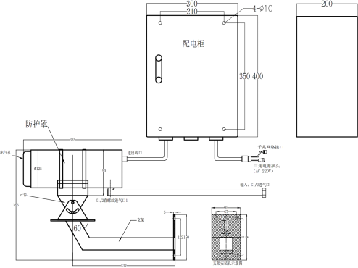

**8** **Division of labor between the two parties**

**Supplier：**

1) Provide manufacturing, transportation, installation guidance and commissioning services for the HIRDA-L steel ladle intelligent diagnosis and analysis system to ensure the normal operation of the system, ensure the integrity of the system, and meet the requirements of on-site use;

2) Responsible for selecting the installation location of the HIRDA-L steel ladle intelligent diagnosis and analysis system equipment, and provide the equipment installation location map before construction;

3) Responsible for training the purchaser's personnel on the commissioning, use, maintenance and overhaul of the HIRDA-L ladle intelligent diagnosis and analysis system, so that the purchaser's personnel can master the operation skills independently;

4) Provide product certificates, inspection reports, operating and maintenance instructions and other relevant technical information.

The demander**：**

1) Provide the relevant on-site data and design drawings required for the installation and commissioning of the HIRDA-L ladle intelligent diagnosis and analysis system.

2) Undertake the piping, wiring and optical fiber melting work for the cooling gas (cooling water), optical fiber and cables required for the HIRDA-L ladle intelligent diagnosis and analysis system.

3) Determine whether the site has the installation conditions required by the supplier, and notify the supplier's technical personnel in advance to participate in the guidance of installation and commissioning.

4) The buyer assists in providing working conditions for the supplier's on-site service personnel.

**9** **Acceptance Criteria**

1) The infrared thermal image and 3D model of the ladle can be displayed on the software interface of the HIRDA-L ladle intelligent diagnosis and analysis system. When the cooling gas meets the use requirements, the equipment maintains a good working effect;

2) The ladle number and use status of the currently monitored ladle can be displayed, and historical maintenance data can be checked;

3) The abnormal temperature area on the ladle surface can be displayed, and an alarm will be prompted;

4) The supplier provides professional training for the designated personnel of the purchaser.

**10** **After-sales commitment**

1) The warranty period of the HIRDA-L ladle intelligent diagnosis and analysis system is 12 months from the date of acceptance or 18 months after the equipment arrives (the warranty period of purchased products, servers and internal hardware is 12 months from the date of equipment arrival).

2) If the thermal imager is damaged due to water or gas outage, the buyer shall order spare parts in time and the supplier shall provide maintenance services.

3) The HIRDA-L ladle intelligent diagnosis and analysis system software is used for a long time, and software upgrade services are provided free of charge.

4) When receiving a call from the buyer, the supplier is responsible for guiding the buyer to handle the fault; if the buyer cannot solve the problem, the supplier promises to rush to the site within 48 hours to handle it. Company service phone: 400-080-4288.