HIRDA-MI
Molten iron temperature continuous detection system
Technical solution

Wuhan Huajingkang Optoelectronics Technology Co., Ltd. February 2024

CONTENTS
1 Overview 3
2 System Introduction 3
2.1 Product Description 3
2.2 System Features 4
2.3 System Utility Requirements 4
2.3.1 power supply 5
2.3.2 Compressed air or nitrogen 5
3 System composition 5
3.1 High temperature short wave infrared thermal imaging thermometer 5
3.2 Overall size 6
3.3 On-site control box 6
3.4 High temperature resistant cables 7
3.5 Image algorithm server 7
3.6 Mounting accessories 8
4 System Software 8
4.1 Software interface 8
5 Configuration List 9
6 On-site installation diagram 10
7 Division of labor between the two parties 10
8 Acceptance Criteria 11
9 After-sales commitment 11

HIRDA-MI molten iron temperature continuous monitoring system
Technical Solution

1 Overview
As an important part of the metallurgical industry, the temperature measurement of molten iron is completed by manual observation, thermocouples, and temperature guns. The working environment is harsh, and the temperature of the molten iron needs to be measured many times. The labor intensity is high, the number of temperature measurements is small, and only 1 to 3 times are measured each time the iron is tapped. Continuous temperature measurement cannot be achieved. In addition, thermocouples are consumables, the cost is high, and the operation method is relatively backward. The fluctuation of workers' operating norms makes the monitoring of molten iron temperature not accurate enough, and cannot reflect the temperature situation and change trend of the entire tapping process. In particular, the environment in front of the blast furnace is harsh, high temperature, dusty, and highly dangerous. Since the ironmaking process in the blast furnace is fully enclosed, it is difficult to measure the temperature directly in the furnace. We need to understand and control the temperature state of the molten iron through external temperature measurement.
If the temperature of molten iron is too low, it will affect the smooth operation of the blast furnace. For a long time, it will cause serious consequences such as the furnace body sticking, abnormal furnace shape, abnormal furnace condition and endangerment of safe production. In addition, molten iron temperature detection provides the most direct and effective detection method for low-silicon smelting. Under the premise of ensuring sufficient physical temperature, the silicon content can be reduced as much as possible, thereby reducing the coke ratio, which is beneficial to the steelmaking process. Molten iron temperature is of great significance to blast furnace operation, so it is necessary to establish a safe and intelligent taphole continuous temperature measurement system.
Our company has developed a new type of continuous temperature measurement system for molten iron. This system can directly measure the temperature of the iron flow at the tapping point, eliminate the temperature drop and temperature uniformity caused by the main ditch and slag skimmer, and more directly and accurately represent the state and change process of the physical heat of the furnace. It also has the outstanding characteristics of strong anti-smoke and dust interference ability, long measurement distance, flexible target alignment and accurate measurement.
The measurement results of the molten iron temperature are transmitted to the host computer in the main control room through the signal line, and a special program is used to collect, process, display and store the data.

2 System Introduction

2.1 Product Description
HIRDA-MI molten iron temperature continuous detection system is a high-tech system specially used for detecting molten iron temperature and conducting intelligent analysis. The system consists of a high-temperature infrared thermal imaging thermometer, a field equipment box, an image algorithm server, and a client management software. Each taphole is equipped with a taphole molten iron continuous temperature measurement device. The taphole molten iron continuous temperature measurement device is installed at a suitable position near the taphole and is cooled and dustproofed by compressed air. When tapping iron, the taphole molten iron continuous temperature measurement device can simultaneously obtain the image and temperature of the molten iron flow, can capture clear molten iron flow images, can measure accurate taphole molten iron flow temperature field distribution (including taphole molten iron temperature and iron slag temperature), and display real-time infrared video of the molten iron flow when tapping iron.
The data obtained by the continuous temperature measurement system of molten iron is transmitted to the industrial computer in the main control room of the blast furnace through optical fiber for real-time display of the molten iron temperature and data storage. It can automatically detect the iron-out status of each taphole in real time and record the start time, end time and duration of each taphole.

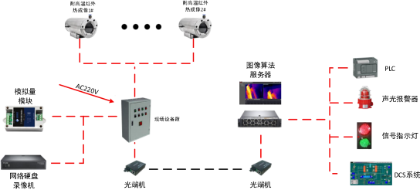

Figure 1 HIRDA-MI system block diagram

2.2 System Features
l High temperature resistant design, can withstand up to 200℃ ambient temperature；
l High protection level, protection grade up to IP66；
l Automatic window cleaning, no need for manual window cleaning；
l Full-screen real-time temperature measurement with wide coverage；
l Not only dependent on the system platform, you can directly log in to the web page IP to access images and configurations, and can directly output alarm signals to PLC or alarms；
l Support GB28181, onvif protocol, can be connected to mainstream NVR；
l Temperature data can be connected to LED screen and PLC；
l Electric/automatic focus, focus operation can be performed at any time through software；
l Temperature range 800℃ to 1800℃;
l Temperature measurement accuracy ≤1%；
l Supports modbus protocol and can be connected to DCS system to transmit temperature data.

2.3 System Utility Requirements

2.3.1 power supply
On-site probe power supply: 220VAC 50/60HZ Power 150W/set
Control room power supply: 220VAC 50/60HZ Power 100W

2.3.2 Compressed air or nitrogen
Compressed air temperature：≤35℃
Compressed air pressure： ≥0.4 Mpa
Compressed air flow：0.1-0.2m/MinF

3 System composition
HIRDA-MI molten iron temperature continuous detection system consists of high-temperature short-wave infrared thermal imaging thermometer, field equipment box, image data server, etc.

3.1 High temperature short wave infrared thermal imaging thermometer

Model | PFCDG320-G
Product image | 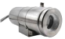
Image resolution | 384×288 | 640×480
Lens options | 25mm 、35mm 、50mm
Temperature resolution | 0.5℃
Frame rate | 25Hz
Image algorithm | Gamma correction, enhancement algorithm
Temperature measurement accuracy | ≤1%
Temperature measurement range | 800℃~1800℃
Network video compression format | H.264/ H.265
Data type | H264 、H265 、16Bit Raw temperature data
Network standard | Gigabit Ethernet/Adaptive 10M/ 100M/ 1000M
Protocol support | IPv4/ IPv6、TCP、UDP、NTP、HTTP、RTSP、RTP、ICMP、WebSocket、 ONVIF
Temperature output | Support analog quantity 4--20ma 、RS485
Protection level | IP66
Dimensions | Φ126mm×351mm
Installation method | Equipped with PTZ bracket
Weight | ≤8Kg
Operating temperature | -20～200℃

3.2 Overall size
The overall structure dimensions are shown in the figure below:

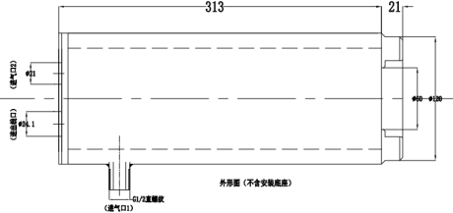

3.3 On-site control box
The electric control cabinet contains an industrial Ethernet switch (photoelectric conversion) and a power adapter. Its main function is to provide a stable power supply for the infrared thermal imager, network switching (photoelectric conversion), and data conversion.
n Input interface: 100M/1000M Ethernet, RJ45 interface
n Output interface: 1000M optical port
n Transmission rate: up to 1000M
n Standard: IEEE802.3, IEEE802.3u, IEEE802.3x
n power supply：AC 220V±10% 50W
n Ambient temperature：-20℃~65℃
n Ambient humidity：≤90%
n Dimensions： 400（W） ×300（H） ×200（D）mm
n Dimensional drawings

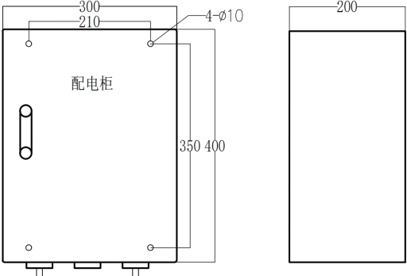

3.4 High temperature resistant cables
As the ambient temperature at the work site is generally high, in order to ensure the stability and reliability of communication and video transmission, the cables are selected to be high temperature resistant, fire resistant, and shielded cables.
The main technical parameters are as follows：
u Rated temperature: -65℃~+250℃ (maximum ambient temperature: 250℃, minimum ambient temperature: -65℃)
u Rated voltage: 600V
u Implementation standard: GJB773A-2000
u Conductor: multi-strand tinned copper wire
u Color: red, black DC12V 0.5m2; orange and white, orange, green and white, green, blue and white, blue, gray and white, gray network cable.
u Insulator: Polytetrafluoroethylene (PTFE)
u Performance: corrosion resistance, strong acid resistance, strong alkali resistance, oxidation resistance; high voltage resistance, non-flammable, non-aging
u Test voltage: 7000V without breakdown

3.5 Image algorithm server

n Intel® Core™ i7-11700 processor (quad-core, 8MB, 3.60GHz)
n Memory 16GB 1600MHz DDR3 Non-ECC
n Hard Drive 256G SSD + 1TB 3.5-inch SATA (7,200 Rpm) Hard Drive
n Monitor 23.8 inches
n Windows 10 Pro, 64-bit operating system

3.6 Mounting accessories

n Air Filter
n 2 x 5m stainless steel air hoses
n 1 x 10m high temperature resistant cable
n Adjustable pan/tilt bracket
n The pre-installation assembly and pre-commissioning are completed at the factory

4 System Software

4.1 Software interface
The system client software interface is shown in the figure below:
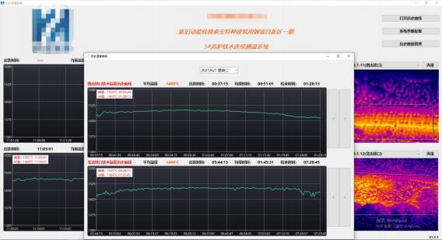
Figure 2 System software interface
The basic functions of the software are as follows：
l The temperature of molten iron is displayed in real time, and the curve is updated once per second. The horizontal axis displays time, and continuously displays the temperature change curve of the whole process of iron production.

l Automatically record the start time, end time and duration of iron tapping.
l Real-time video clearly shows the tapping situation at the tap hole, and the photosensitivity brightness can be adjusted.
l Prompt the measured abnormal temperature. When the temperature exceeds the set range, HIGH or LOW is displayed.
l Real-time automatic detection of the tapping status of each tapping hole. The main page automatically switches the detected tapping hole to realize automatic detection and judgment of the tapping hole.
l Automatically save the current temperature and average temperature. Save the monitoring interface every 30 minutes. Save the current tapping monitoring interface after tapping.
l The historical data and monitoring interface can be queried, the temperature value is saved for ≥2 months, and the monitoring interface screenshot is saved for ≥6 months.
l It can overcome the interference of factors such as dust and high temperature on site, and measure the accurate distribution of the temperature field of the taphole molten iron flow, including the taphole molten iron temperature and the taphole slag temperature.
l It can be connected to the LED screen through ModBus protocol, analog output, etc. to display the temperature.

5 Configuration List

Serial number | Name | Model | Unit | Quantity | Remark
1 | High-temperature short-wave infrared thermal imaging thermometer | PFCDG320-G | Set |  | Resolution:  Focal length:  Temperature measurement range:
2 | Electric control cabinet | SEB432 | Piece
3 | Image algorithm server | IDS | Set |  | Including hardware and software, Display
4 | Air compressor | YBM-15A | Set |  | Optional
5 | Cold dryer | S-100AFB | Set |  | Optional
6 | High-temperature metal hose | φ 12mm | Set
7 | Supporting cables | / | Set |  | High temperature resistant cables
8 | Installation accessories | HIRDA-FJ | Set |  | Including mounting bracket and adjustable pan/tilt
9 | 4-20mA conversion module | HIRDA-DA | Set |  | Optional

6 On-site installation diagram

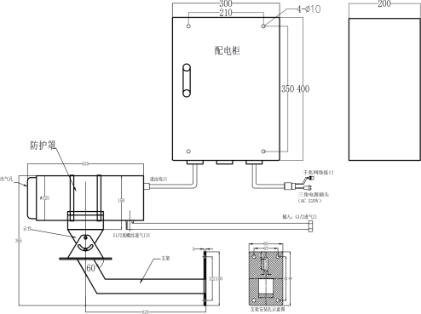

7 Division of labor between the two parties
Supplier：
1) Provide manufacturing, transportation, installation guidance and commissioning services for the HIRDA-MI molten iron temperature continuous detection system to ensure the normal operation of the system, ensure the integrity of the system, and meet the requirements of on-site use.
2) Responsible for selecting the installation location of the HIRDA-MI molten iron temperature continuous detection system equipment, and provide the equipment installation location map before construction.
3) Responsible for training the purchaser's personnel on the commissioning, use, maintenance and overhaul of the HIRDA-MI molten iron temperature continuous detection system, so that the purchaser's personnel can master the operating skills independently.
4) Provide relevant technical information such as product certificates, inspection reports, and instructions for use and maintenance.
Demand side：
1) Provide the relevant on-site data and design drawings required for the installation and commissioning of the HIRDA-MI molten iron temperature continuous detection system equipment.
2) Undertake the piping, wiring and optical fiber melting work for the cooling gas, optical fiber and cables required for the HIRDA-MI molten iron temperature continuous detection system equipment.
3) Determine that the site has the installation conditions required by the supplier, and notify the supplier's technical personnel in advance to participate in the guidance installation and commissioning.
4) The buyer assists in providing working conditions for the supplier's factory service personnel.

8 Acceptance Criteria
1) The infrared thermal image of molten iron can be displayed on the software interface of the HIRDA-MI molten iron temperature continuous detection system. When the cooling air meets the use requirements, the equipment maintains good working effect;
2) The abnormal molten iron temperature area is displayed and an alarm is prompted;
3) The supplier provides professional training to the designated personnel of the purchaser.

9 After-sales commitment
1) The warranty period of HIRDA-MI molten iron temperature continuous detection system is 12 months from the date of acceptance or 18 months after the equipment arrives (the warranty period of purchased products, servers and internal hardware is 12 months from the date of equipment arrival).
2) If the thermal imager is damaged due to improper use, the buyer shall order spare parts in time and the supplier shall provide maintenance services.
3) The HIRDA-MI molten iron temperature continuous detection system software is used for a long time, and software upgrade services are provided free of charge.
4) When receiving a call from the buyer, the supplier is responsible for guiding the buyer to handle the fault; if the buyer cannot solve the problem, the supplier promises to rush to the site within 48 hours to handle it. Company service phone: 400-080-4288.

