**HIRDA-S series sintering machine tail**

**Infrared thermal imaging online temperature detection and analysis system**

**Technical solution**

contents

1 Overview 3

2 System Introduction 3

2.1 Product Description 3

2.2 How it works 4

2.3 Features 4

2.4 System Utility Requirements 5

2.3.1 power supply 5

2.3.2 Compressed air or nitrogen 5

2.3.3 Cooling water 5

3 Main technical indicators 5

4 System composition 6

4.1 High temperature resistant probe 6

4.2 High temperature resistant infrared lens 6

4.3 Pneumatic advance and retreat device 7

4.4 Embedded parts 7

4.5 Control cabinet 8

4.6 Stainless steel hose 9

4.7 High temperature resistant cables 9

4.8 Optical cable and interface (on demand) 10

5 System Software 10

6 System wiring diagram 11

7 Configuration List 12

8 Division of labor between the two parties 12

9 Acceptance Criteria 13

10 After-sales commitment 13

**HIRDA-S sintering machine tail**

**Infrared thermal imaging online temperature detection and analysis system**

**Technical solution**

**1 Overview**

Sintered ore is the main raw material for ironmaking. In order to operate the blast furnace most efficiently, the sintering machine is expected to produce uniform sintered ore with the best performance. To produce stable sintered products, the sintering process must be fully controlled. However, sintering production is a dynamic and complex process involving a large number of parameters. At present, domestic steel companies control the sintering process itself by observing the cross section of the sintered cake at the tail of the sintering machine.

The tail of the sintering machine is the end point of the sintering process. The degree of burn-through of the sintered ore bed at the tail directly reflects whether the machine speed of the sintering machine is reasonable, the permeability of the material layer, and the fuel ratio. It is one of the important qualitative indicators for production adjustment.

**2 System Introduction**

**2.1 Product Description**

The HIRDA-S series sintering machine tail infrared thermal imaging online temperature detection and analysis system is a special equipment specially used in high temperature environment. The system consists of infrared thermal imaging movement, high temperature resistant infrared thermal imaging lens, automatic retraction protection device, furnace wall installation kit, air filtration system and field equipment box, algorithm server and intelligent temperature measurement software.

The high temperature resistant infrared thermal imaging lens is installed in a retractable metal protective cover. The high temperature resistant infrared thermal imaging lens is directly extended into the tail of the sintering machine through the retractable device. The infrared thermal imaging core stays outside the furnace to realize real-time monitoring of the cross-section temperature of the sintered cake at the tail of the sintering machine.

The shield is cooled by compressed cooling air or cooling water, so that the infrared lens can work at a more suitable temperature; at the same time, the lens is purged to prevent dust in the furnace from adhering to the lens protection window; the system has a built-in high-protection circuit, which will retract the lens once the cooling gas or cooling water circulation is abnormal to prevent damage by the high temperature in the furnace.

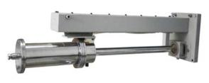

Figure 1 High temperature resistant endoscopic infrared thermal imaging product

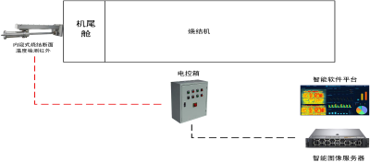

Figure 2 Block diagram of the HIRDA-S sintering machine tail infrared thermal imaging temperature detection and analysis system

**2.2** working principle

The infrared image of the sintered cake section at the tail discharge area of the sintering machine can directly reflect the information of the material layer status, which is a comprehensive response of the sintering production process and can be used as the main basis for controlling the heat level in the sintering material layer. The system determines the sintering quality indicators and the reasonable values of various operating parameters based on the established sintering endpoint prediction model through the brightness, color, size, distribution and position of the red heat bands in the adjacent tail sections of the sintering machine, the integrity of the sintered cake discharge and the size of the dust.

The sintering endpoint prediction model accurately forms the red layer image of the tail section through infrared thermal imaging, uses image preprocessing to extract the area, center of gravity, perimeter and other features of the red fire layer in the sintering tail section image, and extracts the characteristic parameters such as the average brightness and average area value of the sintering pores related to the FeO content. By establishing the inference rules related to the sintering tail section image features and combining them with the extracted characteristic parameters, the method of comparing the brightness of the red fire layer between each frame of the sintering tail video is used to accurately find the key frame of the sintering tail section. The sintering quality information and the image are displayed at the same time. At the same time, data analysis, FeO prediction and other technologies are used to provide decision-making information for sintering control production, guiding the production control operations of the sintering endpoint model and ignition optimization model.

**2.3 Features**

▲ Sintered cake cross section infrared image acquisition and temperature distribution display；

▲ Analysis of relevant information on the tail section of sintering machine；

▲ Establishment of a model for the change trend of FeO content in sintered ore；

▲ Endoscopic high temperature resistant stainless steel protective cover can probe into the tail cover to collect data；

▲ The telescopic length can be customized according to the wall thickness；

▲ Spiral air curtain design, no dust accumulation on the lens；

▲ Automatically exit the protection device and exit the fault indication；

▲ Automatic exit in case of over temperature, under voltage or power failure.

**2.4 System Utility Requirements**

**2.3.1 power supply**

Field probe power supply: 220VAC 50/60HZ power 150W/set

Control room power supply: 220VAC 50/60HZ power 100W

**2.3.2 Compressed air or nitrogen**

Compressed air temperature：≤35℃

Compressed air pressure：≥0.4 Mpa

Compressed air flow：0.1-0.2m3/min

**2.3.3 Cooling water**

Cooling water temperature：≤35℃

Cooling water pressure：≥0.4 Mpa

Cooling water flow：30 升/Min

**3 Main technical indicators**

|  |  |  |  |
| --- | --- | --- | --- |
| Operating ambient temperature | Furnace temperature | | ≦2000℃ |
| Control System | | ≦70℃ |
| Automatic exit device | Automatic exit protection function | | power failure、Stop gas、Over temperature、The probe can automatically withdraw from the furnace when underpressure |
| Exit device trip | | 100-800mm ，Can be customized according to furnace thickness |
| Manual in and out function | | have |
| Controls | Integrated touch screen system | | 8 relays, 4 transistors |
| Three-site control | | It can realize the operation from three places: on-site central control and mobile phone |
| Infrared thermal imaging | Detector Type | | Uncooled focal plane detector |
| Resolution | | 640×480、384×288 |
| Lens focal length | | 8mm、10mm、12mm Adapt to various focal lengths |
|  | Lenses type | | High temperature resistant lens |
| Temperature measurement range | | 50℃~2000℃ |
| Temperature measurement accuracy | | ±2℃or 2% |
| Network Protocol | | 支持  ONVIF/RTSP/FTP/PPPOE/DHCP/DDNS/NTP/UPnP/  TCP |
| Vortex cooling tube (optional) | When the compressed air inlet pressure is ≧0.35MP, the compressed air outlet temperature difference is 23 degrees | | |
| Power supply requirements | Supply voltage | AC220V±10% | |
| Power supply frequency | 50Hz | |
| Installation distance | The maximum distance between the device and the on-site control box is 15M | | |

**4 System composition**

**4.1 High temperature resistant probe**

The high temperature resistant probe adopts an integrated design and has protection functions against high temperature, high pressure, corrosion, power failure, gas failure, etc. The integrated probe integrates a high temperature infrared lens, infrared thermal imaging and pneumatic advance and retreat device.

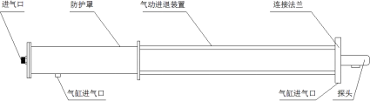

**4.2 High temperature resistant infrared lens**

The housing of the high temperature resistant infrared lens is made of stainless steel, the front end imaging high temperature resistant infrared lens, and the reserved flange connection port is connected to the infrared thermal imaging. The technical parameters are as follows：

▲ Focal length: 8mm, 10mm, 12mm and other focal lengths are available；

▲ High temperature resistance: ≤2000℃ (with cooling device)；

▲ Low temperature resistance: -40℃;

▲ Cooling medium: Compressed air (oil-free and water-free)；

▲ Air inlet: Φ12, ZG1/2″；

▲ Inlet pressure：0.1～0.4MPa；

▲ Cylinder air inlet： Φ12 、ZG1/4 ″；

▲ Cylinder intake pressure：0.1～0.4MPa；

▲ Ambient humidity：10~90% ，No condensation；

**4.3 Pneumatic advance and retreat device**

The high temperature probe is integrated into the pneumatic transmission device, and the camera probe is moved forward and backward by the reciprocating motion of the cylinder piston. Advance and retreat indicators are installed on both sides of the front end of the pneumatic device to indicate the "advance" and "retraction" of the camera probe. The internal components of the cylinder are made of high temperature and wear-resistant materials, suitable for operation in high temperature, corrosive and high dust environments.







The main technical parameters are as follows：

▲ Cylinder diameter： Φ100

▲ Work schedule：Can be customized according to furnace wall thickness

▲ Ambient temperature：-40℃~250℃

▲ Air Inlet： Φ12 、ZG1/4 ″

▲ Cylinder intake pressure 0.1～0.4MPa

**4.4 Embedded parts**

When installing the equipment, the embedded parts are pre-installed in the monitoring hole and connected to the camera probe with a special flange. The embedded parts are made of high-temperature resistant stainless steel and equipped with a special installation guard plate to close the periphery of the monitoring hole and connect the embedded parts. The camera probe advance and retreat indicator pointers are installed on both sides of the embedded parts. The rear end of the embedded parts is installed with an automatic door. When the camera probe is pushed forward, the automatic door is pushed open by the front end of the probe. When the camera probe is withdrawn, the automatic door automatically closes to protect the camera probe from being damaged by high-temperature dust inside the kiln after it withdraws from the monitoring position due to the lack of protective compressed air.

The main technical parameters are as follows：

▲ Installation diameter： Φ108（standard）

▲ Buried depth: Determined by the thickness of the furnace wall

▲ Ambient temperature: 1200℃ (without cooling), 1800℃ (with cooling)

▲ Cooling medium: Compressed air

▲ Air Inlet： Φ12 、ZG1/2 ″

▲ Inlet pressure：0.05～0.6MPa

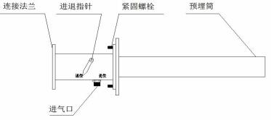

**4.5 Control cabinet**

The control cabinet provides working power to the camera probe and automatically controls the advance and retreat of the probe. It receives coded instructions from the operator and drives the various control functions of the camera probe after conversion. The control cabinet can control the camera probe by connecting to the operation controller.

The main technical parameters are as follows：

▲ Power supply：220VAC/50Hz

▲ Power consumption：50W

▲ Control Input：RS485

▲ Control output: switch

▲ Power Output：12VDC/1.5A

▲ Video input: IP network

▲ Video output: Network, optical fiber SC interface

▲ Temperature control: 0-60 degrees

▲ Gas supply index: 0.4MPa～1MPa, temperature ≤40℃, flow rate ≥3m3/h

▲ Cylinder working gas: 0.1 MPa~0.2 MPa, solenoid valve, two-way

▲ Cooling air: 0.1 MPa～0.3MPa, flow rate ≥2m3/h

▲ Purge gas: 0.1 MPa～0.3 MPa, with self-contained air filtration, flow rate ≥0.2 m3/h

▲ Protection level：IP65

▲ Dimensions：700 (width) × 500 (height) × 200 (depth)

▲ Mounting hole size: 640 (width) × 400 (height) × Φ10

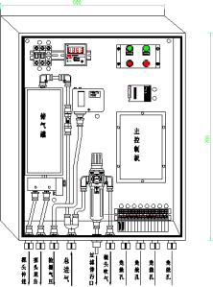

**4.6 Stainless steel hose**

Stainless steel hoses are resistant to high temperature, high pressure and corrosion. To facilitate the movement of the camera probe, the cable and compressed air connected to the camera probe use stainless steel hoses as the connecting medium.

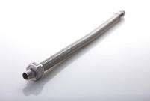

▲ Path： Φ12 、 Φ10 、 Φ8 、 Φ6

▲ Interface：ZG1/2 ″

▲ Material：Heat resistant stainless steel

**4.7 High temperature resistant cables**

As the ambient temperature at the work site is generally high, in order to ensure the stability and reliability of communication and video transmission, the cables are selected to be high temperature resistant, fire resistant, and shielded cables.

The main technical parameters are as follows：

▲ Rated temperature: -65℃~+250℃ (maximum ambient temperature: 250℃, minimum ambient temperature: -65℃)

▲ Rated voltage：600V

▲ Implementation Standards：GJB773A-2000

▲ Conductor: multi-strand tinned copper wire

▲ Color: red, black DC12V 0.5m2; orange and white, orange, green and white, green, blue and white, blue, gray and white, gray network cable

▲ Insulation: Polytetrafluoroethylene（PTFE）

▲ Performance: corrosion resistance, strong acid resistance, strong alkali resistance, oxidation resistance; high voltage resistance, non-flammable, non-aging

▲ Test voltage: 7000V without breakdown

**4.8 Optical cable and interface (on demand)**

The control signals and video signals transmitted over long distances are all transmitted using single-mode optical fiber. Optical fiber transmission has the characteristics of high signal quality and anti-interference, and the signal transmission distance can reach more than 20km. In addition, the system is equipped with SC type optical cable interface to facilitate optical cable connection. The technical parameters are as follows:

▲ Fiber type: Single mode

▲ Operating wavelength: 1310nm and 1550nm

▲ Attenuation characteristics: 1310nm wavelength is 0.36dB/km; 1550nm wavelength is 0.21dB/km

▲ Bending loss: Φ75×100 turns, additional bending loss ≤0.5dB

▲ Fiber optic interface: single mode SC

**5 System Software**

The system client software interface is shown in the figure below.

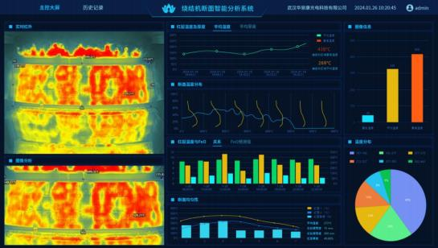

Figure 3 System software interface

The basic functions of the software are as follows：

1、Real-time video display: Real-time display of infrared video images of the sintering machine tail, showing relevant information of the sintering machine tail section, such as: material distribution uniformity, maximum temperature distribution of the section, longitudinal temperature distribution of the section, degree of material layer burn-through, etc.

2、Temperature curve display: Real-time display of the change trend of the sintering machine section temperature over time under different sintering conditions; when monitoring the sintering machine material surface temperature, the highest temperature curve can be displayed in real time, and the change trend of the curve can be used to determine whether there is an abnormality.

3、Data analysis: Based on the sintering process knowledge, analyze the cross-section feature images, extract the process data related to the production quality status, save and display it on the system interface.

4、Temperature compensation: The device can automatically perform temperature compensation according to the actual ambient temperature on site to meet the temperature measurement requirements in different temperature environments.

5、Fault self-diagnosis: When a terminal device fails, the system automatically alarms.

6、Data management: The measured temperature on site is written into the database in real time, and reports and temperature curves are automatically generated. Historical temperature information and alarm records are retrieved to facilitate fault tracking and accident analysis after problems occur.

7、Supports multi-platform open API interface docking. The platform is compatible with other monitoring and detection equipment such as cameras, temperature sensors, etc., truly realizing systematic management；

9、User rights management: Different permissions can be granted to different user groups.

**6 System wiring diagram**

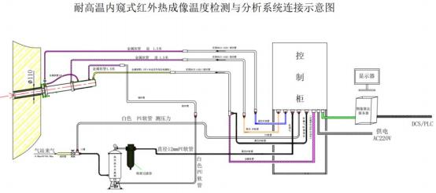

Figure 3 System wiring diagram

**7 Configuration List**

|  |  |  |  |  |  |
| --- | --- | --- | --- | --- | --- |
| Serial number | name | model | unit | quantity | Remark |
| 1 | Infrared thermal imaging movement | NX26Exx | Taiwan |  | Resolution:  Focal length:  Temperature measurement range: |
| 2 | High temperature resistant probe | HIRDA-HTP | piece |  |  |
| 3 | Pneumatic advance and retreat device | HIRDA-CY | piece |  |  |
| 4 | Embedded parts | HIRDA-EMB | piece |  |  |
| 5 | Control cabinet | SEB752 | piece |  |  |
| 6 | Image algorithm server | IDS | piece |  | Including hardware and software, display |
| 7 | Air compressor | YBM-15A | set |  | Optional |
| 8 | Cold dryer | S-100AFB | Taiwan |  | Optional |
| 9 | High temperature metal hose | φ 12mm | Taiwan |  |  |
| 10 | High temperature hose | φ 12mm | set |  |  |
| 11 | Matching cables | / | set |  |  |
| 12 | Installation accessories | HIRDA-FJ | set |  |  |

**8 Division of labor between the two parties**

**Supplier：**

1) Provide manufacturing, transportation, installation guidance and commissioning services for the HIRDA-S sintering machine tail infrared thermal imaging temperature detection and analysis system to ensure the normal operation and integrity of the system and meet the requirements of on-site use.

2) Responsible for selecting the installation location of the HIRDA-S sintering machine tail infrared thermal imaging temperature detection and analysis system equipment, and providing the equipment installation location map before construction.

3) Responsible for training the purchaser's personnel on the commissioning, use, maintenance and overhaul of the HIRDA-S sintering machine tail infrared thermal imaging temperature detection and analysis system, so that the purchaser's personnel can master the operating skills independently.

4) Provide product certificates, inspection reports, operating and maintenance instructions and other relevant technical information.

**Demand side：**

1) Provide relevant on-site data and design drawings required for the installation and commissioning of the HIRDA-S sintering machine tail infrared thermal imaging temperature detection and analysis system equipment.

2) Drill holes at appropriate locations in the kiln and weld embedded parts for equipment installation according to design requirements.

3) Responsible for the piping, wiring and fiber fusion of the cooling air, cooling water, optical fiber and cables required for the HIRDA-S sintering machine tail infrared thermal imaging temperature detection and analysis system equipment.

4) Determine the installation conditions that meet the supplier's requirements, and notify the supplier's technical staff in advance to participate in the installation and commissioning guidance.

5) The demander assists in providing working conditions for the supplier's factory service personnel.

**9 Acceptance Criteria**

1) The production status of the material surface in the kiln can be displayed on the software interface of the HIRDA-S sintering machine tail infrared thermal imaging temperature detection and analysis system. When the cooling air and cooling water meet the use requirements, the thermal imager maintains a good working effect；

2) The system is equipped with cooling water flow monitoring, cooling gas pressure monitoring, entry/exit device, and equipment temperature monitoring device. In the event of insufficient cooling gas or cooling water pressure, cooling gas or cooling water interruption, or excessive temperature of the thermal imager, the system will automatically exit to ensure the safety of the thermal imager and high-temperature lens；

3) The supplier provides professional training to the personnel designated by the buyer.

**10 After-sales commitment**

1) The warranty period of HIRDA-S sintering machine tail infrared thermal imaging temperature detection and analysis system is 12 months from the date of acceptance or 18 months after the equipment arrives (the warranty period of purchased products, servers including internal hardware is 12 months from the date of equipment arrival).

2) If the thermal imager is damaged due to water or gas outage, the buyer will order spare parts in time and the supplier will provide maintenance services.

3) HIRDA-S sintering machine tail infrared thermal imaging temperature detection and analysis system software is used for a long time, and free software upgrade service is provided.

4) When receiving a call from the buyer, the supplier is responsible for guiding the buyer to handle the fault; if the buyer cannot solve the problem, the supplier promises to rush to the site to handle it within 48 hours. Company service phone: 400-080-4288.