# MSFL36KN Online Single Spectrum Infrared Thermal Imaging Temperature Measurement System

**Product Description**

The MSFL36KN online single-spectrum infrared thermal imaging temperature measurement system (water-air cooling) is an integrated online temperature measurement monitoring device, consisting of a tripod or pan/tilt, and a 17μm uncooled infrared thermal imager. Embedded with advanced image processing algorithms, it has the characteristics of low power consumption, fast startup, excellent imaging quality, and accurate temperature measurement.

The device selection of the MSFL36KN online single-spectrum infrared thermal imaging temperature measurement system fully considers the requirements of high and low temperature working performance. The water-air cooling uses air and water to circulate heat at the same time to ensure that the whole machine has excellent environmental adaptability.

**Functional characteristics**

1. It has all-weather passive thermal imaging function, has strong smoke penetration performance, and can be used in a wide range of ambient temperatures;

2. It adopts high frame rate design to observe fast-moving targets;

3. It adopts self-developed temperature measurement and correction algorithm to achieve accurate temperature measurement;

4. Infrared data transmission can be completed with a single network cable, and monitoring and temperature measurement are carried out simultaneously；

5. It is widely used in steel, petrochemical online monitoring and other fields；

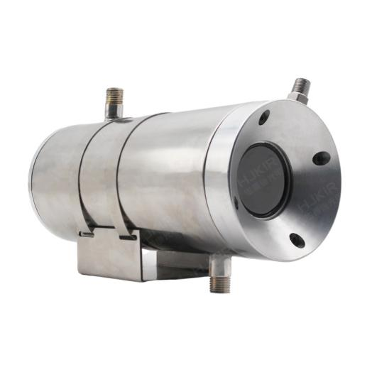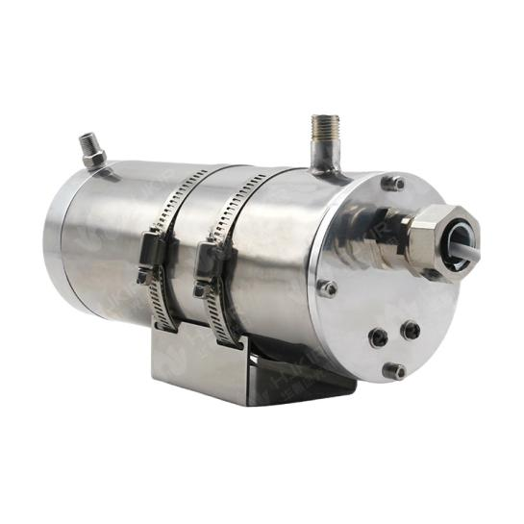

MSFL36KN online single spectrum infrared thermal imaging temperature measurement system diagram

## MSFL36KN Technical Parameters

|  |  |
| --- | --- |
| Applicable movement | |
| Focal length | 8、9.6、13、19、25、35mm(F#1.0) |
| Number of pixels | 384×288/640×480 |
| Camera model | K series/N series |
| Imaging range | 0.3m～∞ |
| Pixel spacing | 17μm |
| Wavelength range | 8～14μm |
| Thermal sensitivity (NETD) | ≤50mk@30℃ |
| Frame rate | ≤50Hz（Configurable） |
| Image processing and display | |
| Imaging time | ≤15S |
| Palette | Multiple color palettes, including white hot, black hot, iron red, rainbow, etc. |
| Data format | 16-bit temperature data (full code stream) |
| Temperature measurement analysis | |
| Temperature measurement range | Normal temperature range: -20℃～200℃  Medium temperature range: 50℃～800℃  High temperature range: 50℃～1600℃ |
| Temperature measurement accuracy | ±2℃ or ±2% |
| Electrical Characteristics | |
| Data interface | RJ45 |
| Network standard | 100M/1000M (100M network needs to reduce frame rate) |
| Protocol support | UDP |
| Power interface | 2EDGKD-3.81mm/2P |
| Input power voltage | 5V～12VDC |
| Communication interface | UART@RS485（Reverse control of gimbal and camera） |
| Steady-state power consumption | <2.2W |
| Reverse connection protection | Yes |
| Over-voltage and under-voltage protection | Yes |
| Environmental parameters | |
| Operating temperature | 0℃～60℃ (temperature measurement accuracy can be guaranteed within the range of 15℃～35℃) |
| Storage temperature | -45℃～70℃ |
| Temperature shock resistance | 5℃/min (-40℃～60℃) |
| Vibration resistance | 4.3g, 2 hours per axis for x, y, and z |
| Shock resistance | 30g acceleration, half sine wave, pulse width 6ms, 3 impacts in the installation and use direction |
| Humidity | ≤95% (non-condensing) |
| Lenses | |
| Focal length | 8、9.6、13、19、25、35mm(F#1.0) |
| Clear imaging range | 0.3m～∞ |
| Physical properties | |
| Dimensions | ø89mm×212mm |
| Weight | 4Kg |
| Mounting holes | 4-ø9Through Hole |
| Cooling system | |
| Working environment temperature | -25℃~+600℃ (air-cooled medium, can withstand 150℃ ambient temperature; water-cooled medium, can withstand 600℃ ambient temperature) |
| Cooling water temperature | ≤35℃ |
| Cooling water pressure | 0.1~0.4Mpa |
| IP protection level | Meet IP66 standard |
| Compressed air temperature | ≤35℃ |
| Compressed air pressure | 0.1Mpa-0.8Mpa |
| Air purge function | The front lens protection germanium sheet is equipped with a wind curtain, which supports air purge function to prevent dust from adhering to the lens surface |
| Client | |
| Real-time temperature display | Support |
| Multiple temperature measurement objects | Support |
| Manual temperature window stretching | Support |
| Photography and analysis | Support |
| Generate reports | Support |
| Common phrase dictionary entry | Support |
| Unit/user/member management | Support |
| SDK development package | |
| Operating Environment | Support win32, x64, Linux (x86, ARM) |

## Interface Diagram

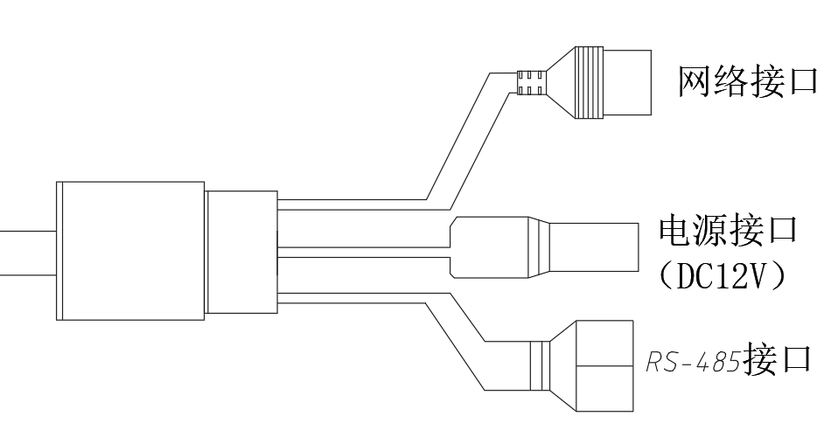

## Structural dimensions

